Chip back potential is the level which bulk silicon is maintained by on-chip connection, or it is the level to which the chip back must be connected when specifically stated below. If no potential is given the chip back should be isolated.

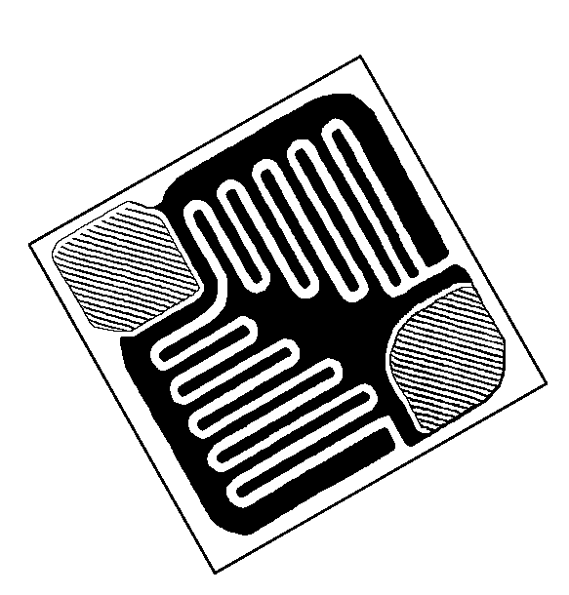
BASE
EMITTER
.016”
.016”

Top Material: Al
Backside Material: Au
Bond Pad Size: .004” X .004” min
Backside Potential: COLLECTOR
Mask Ref:

APPROVED BY: DK DIE SIZE .016” X .016” DATE: 3/28/22
MFG: MOTOROLA THICKNESS .010” P/N: 2N2907A
DG 10.1.2

Rev B, 7/1

